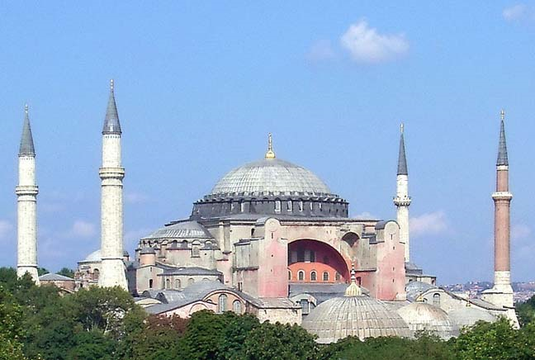
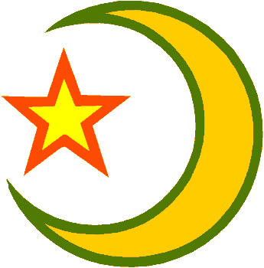
Islamic World

Muhammad was born in . The religion of was revealed to Muhammad.
Prior to Muhammad, most Arabs were (belief in many gods).
Muhammad’s teachings angered the . He believed the rich and poor should be and the rich should give to the poor.
The rich were not happy and began persecuting Muslims.
Because of persecution Muhammad flees to where people were eager to hear his teachings.
Muhammad taught there was only God. And God required people to submit and obey him.
is the name of the Muslim god. Allah literally translates to “god.”
They believed Abraham, Moses, & were earlier prophets.
All Muslims acknowledge the 5 basic duties known as the “ .”
After Muhammad’s death, or successors carried on his mission. They became the highest leaders in Islam.
ISLAMIC WORLD
Islam spread through , ,& .
Islam spread outside the Arabian Peninsula during 600-900 A.D. due to Muslim conquests.
In 1453 the Turks (Muslims) conquered , which became the capital of their empire, The Ottoman Empire.
They changed Hagia Sophia into a .
The Ottoman Empire included much of the Byzantine Empire.
Wherever Muslims ruled there was always a way to distinguish a Muslim from a -Muslim
  - Could not inter
  - Had to pay a special
  - Could not hold
  - Religious temples could not be in the open.

Islam brought with it a system of law, government, and society.
Including great advancements in____________________, ___________________, and science.

